CSC 413.02
Assignment 3: Interpreter
Alonzo Contreras
https://github.com/CSC-413-SFSU-02/csc413-p3-interpreter-alonzocontreras

Introduction:
In this project I was tasked of implementing an interpreter for a mock language. I was given a skeleton code with instructions on how the program should run and what the outcome should be. The instructions asked to implement all the ByteCode classes listed in the CodeTable class. Complete the implementation of ByteCodeLoader, Program, RuntimeStack, and Virtual Machine classes. To make sure all variables created have their correct modifiers. Lastly the most important is to ensure that encapsulation is not broken.
I implemented the project using IntelliJ IDE by creating a new project using existing resources and used the files provided to me. Upon running the program, first one must edit the run configuration and in the program arguments type in the name of the x.cod the user wants to run (i.e. factorial.x.cod). After doing so, all one must do is press the Run button.

Assumptions:
The main assumption that I made was that the user will input the correct file into the configuration for run. As well as the user will enter a valid input when prompted for an integer to run.
When checking for DUMP in the file, the files I tested had to be manually inserted in to it, therefore I made the assumption that the user will type DUMP ON in the file that is being ran. The code given to me to use was assumed to be correct and functioning and all I had to do was implement new code in order to make the program work as intended.

Implementation:
When starting to write the project I read through the pdf given to us which explained what the program should be doing and what each bytecode does. It also gave hints on how to start and what steps I should follow to make sure the program runs smoothly. I started by creating all the bytecode classes given by the hashmap in the CodeTable class given to us.

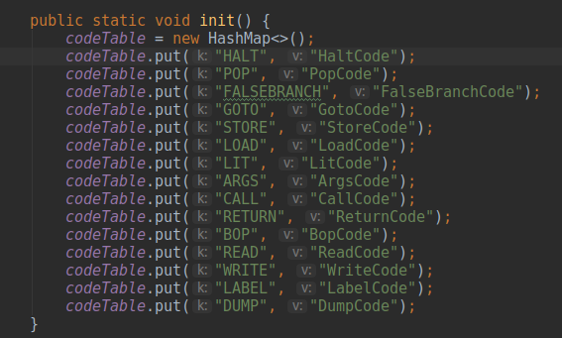
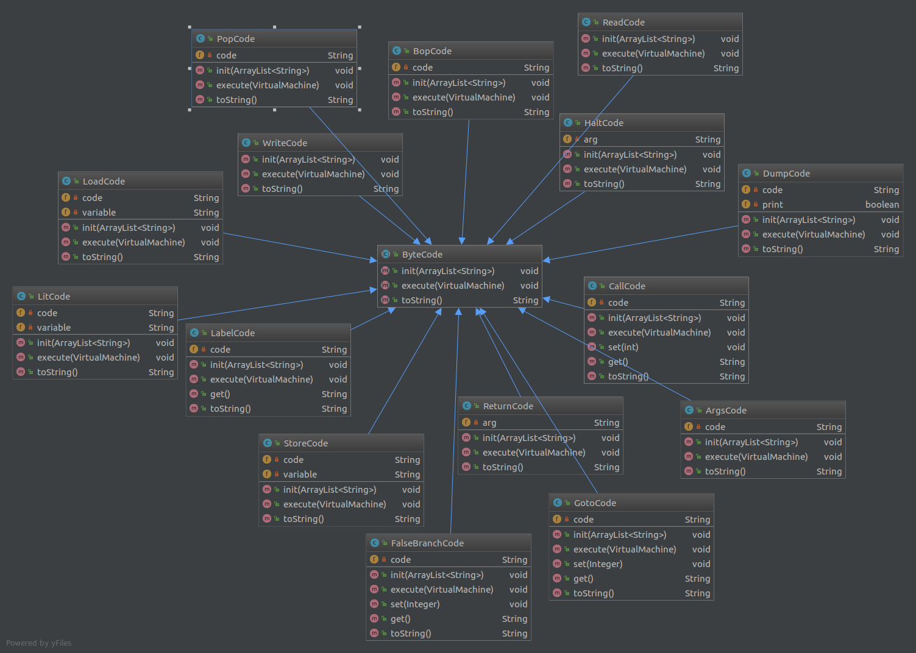
This is the first and only instance of a hierarchy where the parent class is ByteCode and they children are the bytecodes that I implemented. Once I created all the bytecodes, I moved on to the ByteCodeLoader to be able to read what each bytecode does when read from the file. I was given two private fields and one method that instantiated a buffer reader that reads characters, arrays, and lines from a file in an efficient way. I was tasked in implementing a method called loadCodes that would read one line of source code at a time then it would tokenize the string that it read and break it into parts. Once its broken into parts, grab the correct class name for the give bytecode from the CodeTable and create an instance of the bytecode class. Then parse any additional arguments in the string that was tokenize and send them to the newly created bytecode instance by using the init function that I implemented into all the bytecodes.
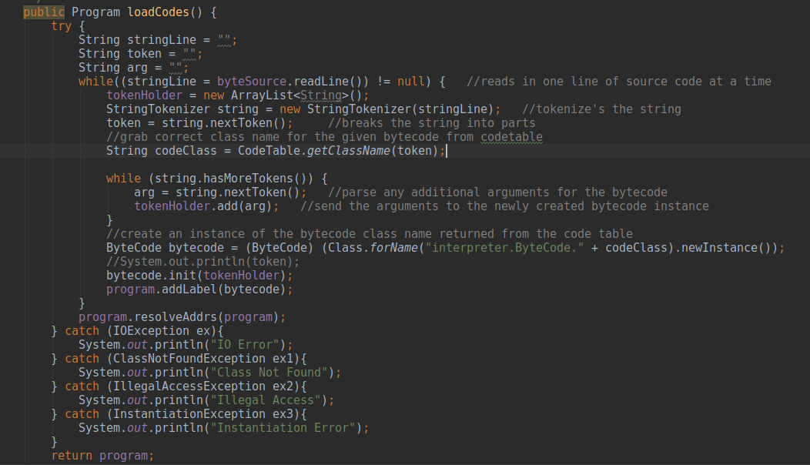
Once ByteCodeLoader was completed I moved on to the Program Class in where I was given a default constructor, two get methods (one for getting the code and one for getting the size of the bytecode), and an addLabel method. I was tasked with implementing resolveAddrs in where the method should go through the program and resolve all the addresses in order for the virtual machine to know what to set the program counter to.

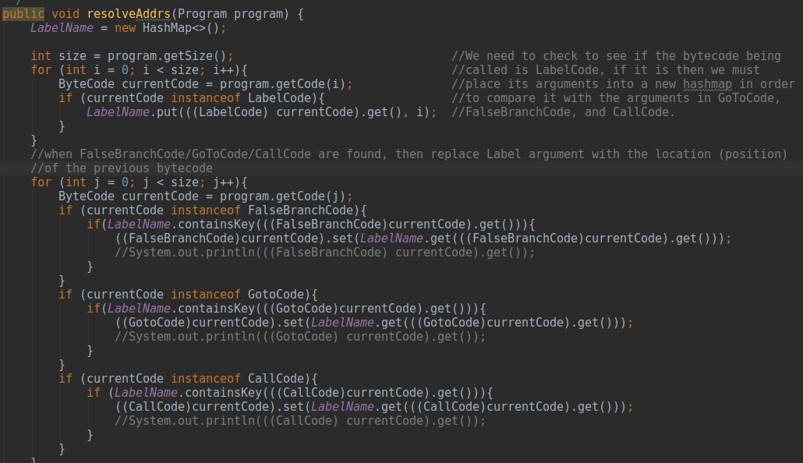
After I finished implementing Program I moved on to VirtualMachine, RunTimeStack, and the individual bytecode since they work in tandem. Working on the bytecodes and implementing what they do from the pdf onto code allowed me to know what methods I needed to implement in both the VirtualMachine as well as the RunTImeStack. In the VirtualMachine the custom constructor as well as the executeProgram method is given to me, all I needed to do was add new methods to use the bytecodes as well as modify the executeProgram for the dump code.
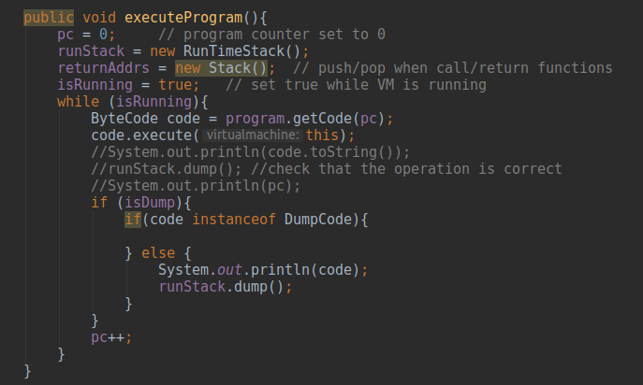
For the RunTimeStack I was provided only with the default constructor,
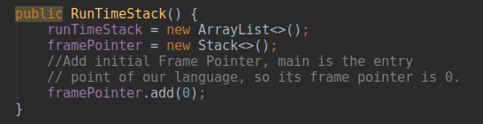
and I had implemented the methods that would add or remove elements from the stack (in this instance the elements are integers). These methods are called from the VirtualMachine and from there from the bytecodes themselves. We do this in order to not break encapsulation. Encapsulation is a process of wrapping code and data together into a single unit, therefore the bytecodes that need access or write into the runtime stack need to call the operations from the virtual machine, then the virtual machine will carry out the operation. The RunTimeStack class maintains the stack of active frames. When we call a function we’ll push a new frame on the stack. When we return a function we’ll pop the top frame. All of this is being ran from the Interpreter Class as seen in the diagram below.
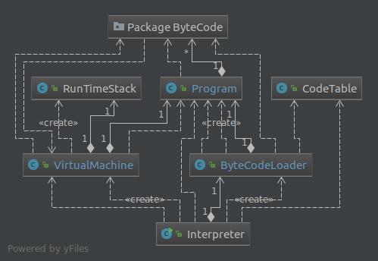

The diagram allows us to see how the Interpreter calls each class except RunTimeStack. Only VirtualMachine calls RunTimeStack in order to keep encapsulation.

Conclusion:
This project allowed me to understand where I stand in my ability to code (my strengths and weaknesses). I was given two weeks to do this project and I only utilized one of those weeks due to other class priorities, but it was still doable. The hardest part that I came across this project was understanding what each byte code was suppose to do when referring to the pdf. This gave me an idea of how much of the project I could understand and what I didn’t. What I did to overcome this was using my peers to help me get over this hurdle. Also suing StackOverflow.com helped a lot as a reference as well as Java Documentation when I came across a data structure I didn’t understand. If I can go back, I would take more time to read over again (multiple times if needed) the pdf and try to understand it more if I could.

